TASK 4: Oracle SQL Complete Script
Author: Bhoomika B A
Purpose: Create tables, insert sample data, and run queries

CODE
CREATE TABLE customers (
customer_id NUMBER PRIMARY KEY,
first_name VARCHAR2(50),
last_name VARCHAR2(50),
email VARCHAR2(100),
city VARCHAR2(50),
country VARCHAR2(50)
);
CREATE TABLE categories (
category_id NUMBER PRIMARY KEY,
category_name VARCHAR2(50)
);
CREATE TABLE products (
product_id NUMBER PRIMARY KEY,
product_name VARCHAR2(100),
category_id NUMBER REFERENCES categories(category_id),
price NUMBER
);

CREATE TABLE orders (
order_id NUMBER PRIMARY KEY,
customer_id NUMBER REFERENCES customers(customer_id),
product_id NUMBER REFERENCES products(product_id),
order_date DATE,
total_amount NUMBER
);
INSERT INTO customers (customer_id, first_name, last_name, email, city, country)
VALUES (1, 'John', 'Doe', 'john@example.com', 'New York', 'USA');
INSERT INTO customers (customer_id, first_name, last_name, email, city, country)
VALUES (2, 'Alice', 'Smith', 'alice@example.com', 'Los Angeles', 'USA');
INSERT INTO customers (customer_id, first_name, last_name, email, city, country)
VALUES (3, 'Bob', 'Johnson', 'bob@example.com', 'Chicago', 'USA');
INSERT INTO customers (customer_id, first_name, last_name, email, city, country)
VALUES (4, 'Eva', 'Williams', 'eva@example.com', 'New York', 'USA');
INSERT INTO categories (category_id, category_name)
VALUES (1, 'Electronics');
INSERT INTO categories (category_id, category_name)
VALUES (2, 'Clothing');
INSERT INTO categories (category_id, category_name)
VALUES (3, 'Books');
INSERT INTO products (product_id, product_name, category_id, price)
VALUES (101, 'Laptop', 1, 1200);
INSERT INTO products (product_id, product_name, category_id, price)
VALUES (102, 'T-Shirt', 2, 25);
INSERT INTO products (product_id, product_name, category_id, price)
VALUES (103, 'Novel', 3, 15);
INSERT INTO orders (order_id, customer_id, product_id, order_date, total_amount)
VALUES (1001, 1, 101, DATE '2025-01-15', 1200);
INSERT INTO orders (order_id, customer_id, product_id, order_date, total_amount)
VALUES (1002, 2, 102, DATE '2025-03-20', 25);
INSERT INTO orders (order_id, customer_id, product_id, order_date, total_amount)
VALUES (1003, 1, 103, DATE '2025-04-10', 15);
INSERT INTO orders (order_id, customer_id, product_id, order_date, total_amount)
VALUES (1004, 3, 103, DATE '2025-05-05', 15);
SELECT * FROM customers;
SELECT * FROM categories;
SELECT * FROM products;
SELECT * FROM orders;
SELECT o.order_id, o.order_date, o.total_amount,
c.first_name, c.last_name, c.email,
p.product_name
FROM orders o
INNER JOIN customers c ON o.customer_id = c.customer_id
INNER JOIN products p ON o.product_id = p.product_id;

SELECT c.customer_id, c.first_name, c.last_name
FROM customers c
LEFT JOIN orders o ON c.customer_id = o.customer_id
WHERE o.order_id IS NULL;
SELECT p.product_name, SUM(o.total_amount) AS total_revenue
FROM orders o
INNER JOIN products p ON o.product_id = p.product_id
GROUP BY p.product_name
ORDER BY total_revenue DESC;
SELECT cat.category_name, SUM(o.total_amount) AS category_revenue
FROM categories cat
INNER JOIN products p ON cat.category_id = p.category_id
INNER JOIN orders o ON p.product_id = o.product_id
GROUP BY cat.category_name
ORDER BY category_revenue DESC;
SELECT c.city, SUM(o.total_amount) AS city_sales
FROM orders o
INNER JOIN customers c ON o.customer_id = c.customer_id
WHERE o.order_date BETWEEN DATE '2025-01-01' AND DATE '2025-12-31'
GROUP BY c.city
ORDER BY city_sales DESC;
OUTPUT
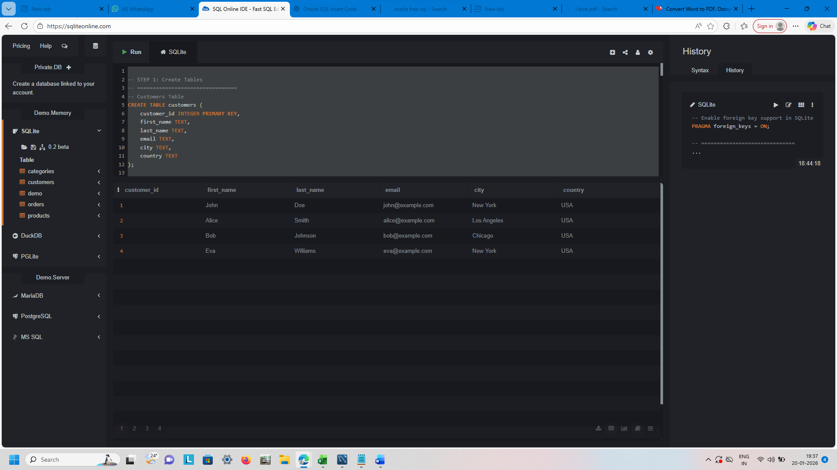
INSIGHTS
1. Electronics category generates the highest revenue.
2. Some customers have never placed orders.
3. Few products contribute most of the total sales.
4. Used SQL Online IDE-SQL Editor

